IBP2012-IVIS-005 Advancing Lines: Making the F3 Nursery

Introduction:
In this tutorial the user will import data for the F2 Nursery, and use this data to select families and lines within families to make the F3 Harvest list.

Objectives:
At the end of this chapter, the user should be able to:
- Generate the F3 and later nursery lists; and
- Generate germplasm derivatives interactively.

Tutorial Steps:

A. Importing the F2 selection data:

- Open the Excel file UCR2010F2.xls you exported from the Breeding manger in the last tutorial. Enter the selection data in the columns CANOPY, NOTES and PLANTS SELCTED (by cutting and pasting the column from the file UCR2010F2H_Data.xls in directory \ICIS5\Document\Training\IVIS). The workbook should look as follows:

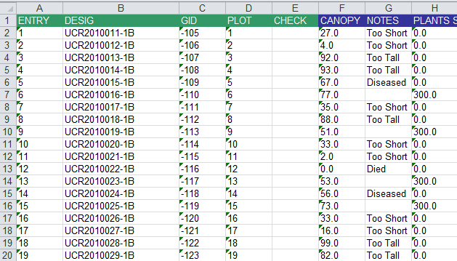

In this fictitious data I have rejects families with CANOPY too short or too tall and selected 300 plants from the remaining families.

- Open the Breeding manager from the Workbench and open the Measurements Tab of the UCR2010F2 nursery.

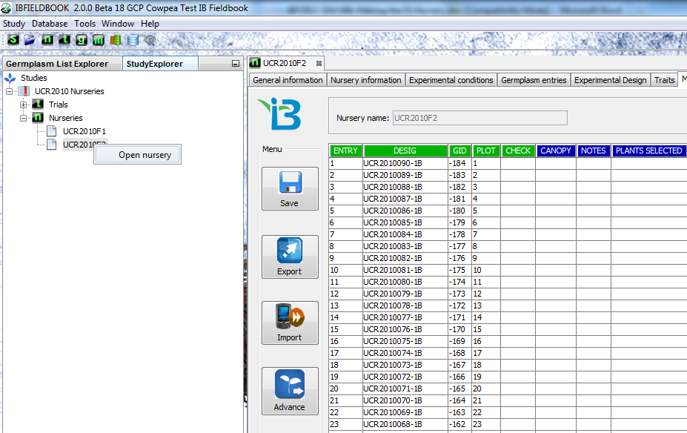

- Click Import, choose excel file, navigate to the directory where you stored the above file and open it to import the data and then click Save.

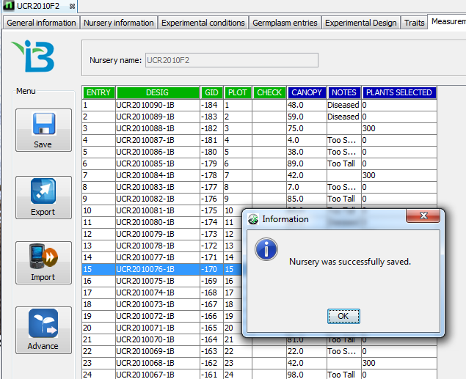

B. Advancing the Nursery

- With the UCR2010F2 nursery open at the Measurements Tab and containing the imported selection data, clock on Advance.

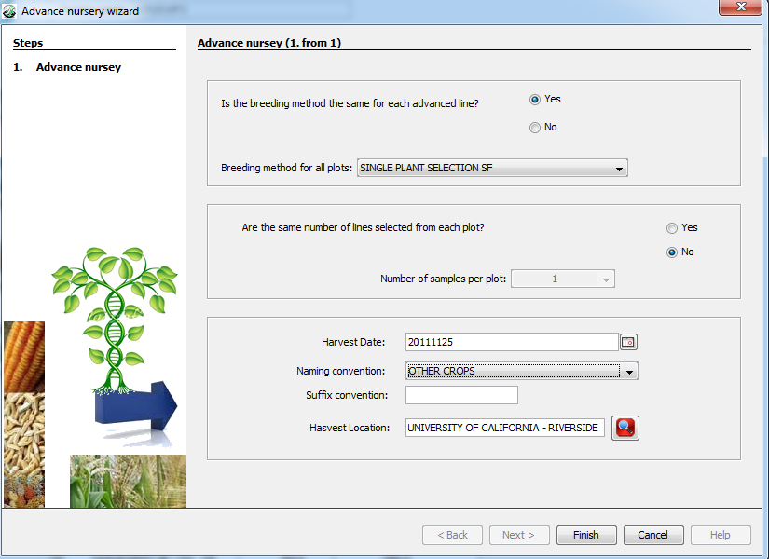

The method is the same for each advanced line (single plant selection), but the same number of lines are not selected from each plot (some plots have none selected and other 300) so answer No to this question. (The program will then look for a variable with property PLANTS SElECTED and get the number for each plot from that variable. Enter a suitable harvest date, select the Other Crops naming convention, and select UCR as the Harvest Location.

- Click ‘Finish’ and you will get a list of candidate lines:

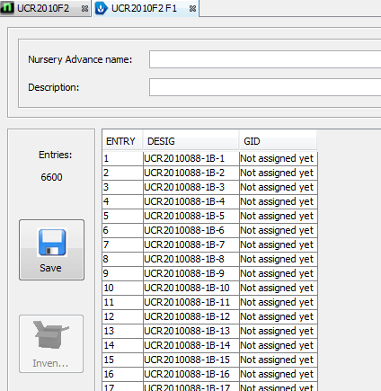

- Enter UCR2011F3 as the list name, and ‘UCR 2011 F3 list (harvest list for F2 Plants) in the List name and description fields and click Save. The saving will take a little while since we are selecting over 6000 lines!

C. Extracting the MARS Population from the F3 List

- Open the Breeding Manager from the Workbench and run the List manager by clicking on the New Germplasm List icon (g) on the tool bar. Open the F3 list which has just been created (UCR2011F3).

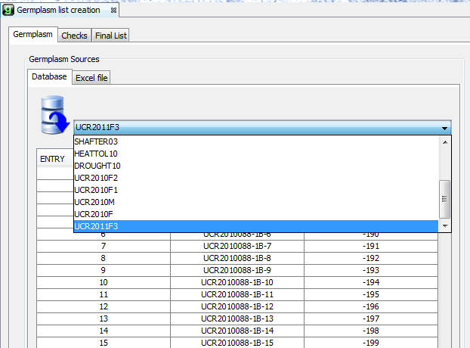

- The MARS population is derived from the UCR2010057 – SUVITA 2 (GOROM LOCAL)/IT 97 K-499-35 so scroll down the list to the first line of the MARS population: UCR2010057-1B-1, and highlight all 300 lines from that population by dragging the curser down to UCR2010057-1B-300.

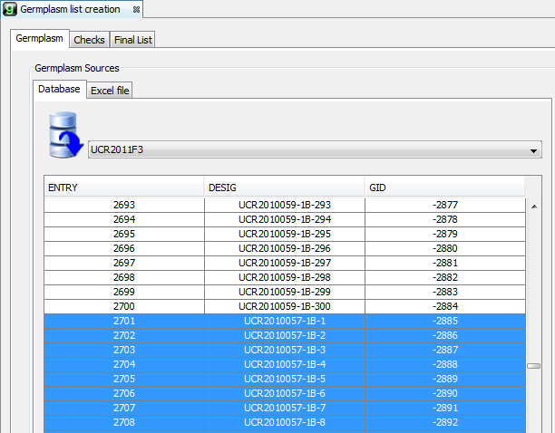
- Drag the 300 selected lines to the New list in the right hand pannel.

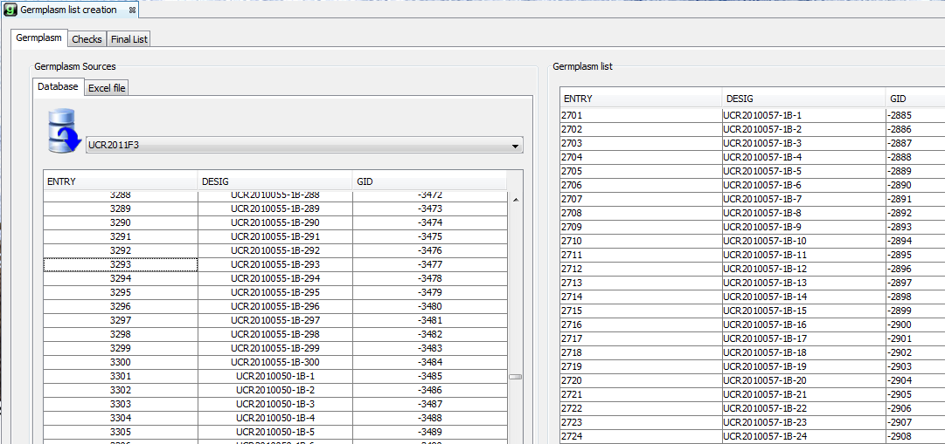

- Click Final List and enter ‘BF2011MARS’ in the Lsit name field, and “ Burkina Faso 2011 MARS Population F2 plant list and F3 harvest list” in the description field. Check “Without Checks” and click Save.

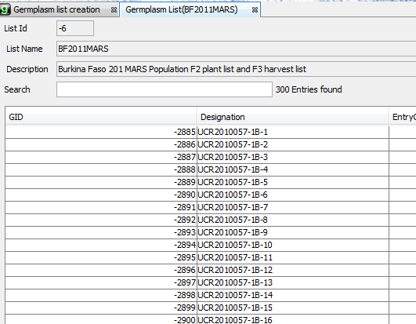

D. Preparing the Genotyping and Phenotyping Nursery Books

- Open the Breeding Manager from the IB Workbench , select “New Study” from the Study Menu and enter the study name “BF2011MARS”, the Title “Burkina Faso 2011 MARS Activities” and the Objective “Phenotype and genotype the MARS population in 2011”, Click the check symbol to create the study.

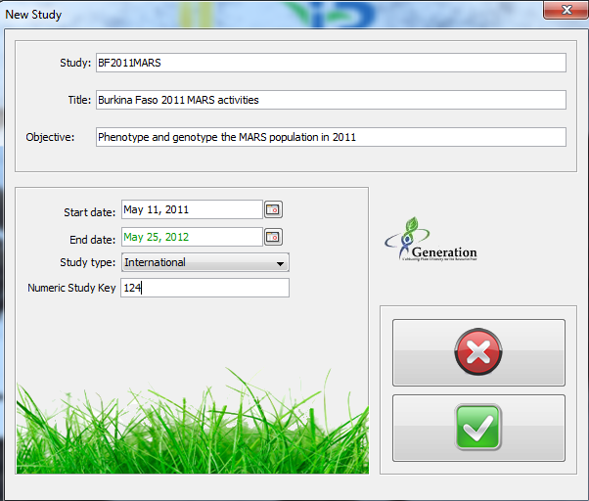

- Open the New Nursery Wizard

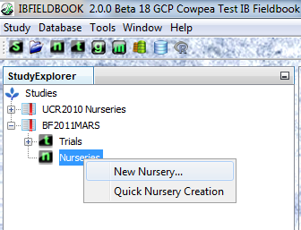

- Select the Cowpea Nursery template, fill in the Study Conditions:

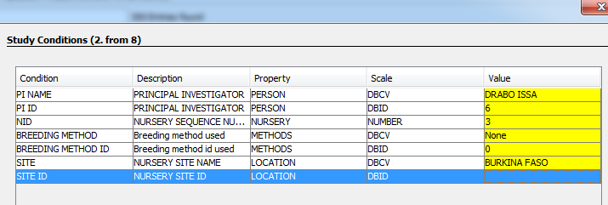

- Select the BF2011MARS List, do not add checks, select NOTES and SEED HARVESTED Traits to be measured.

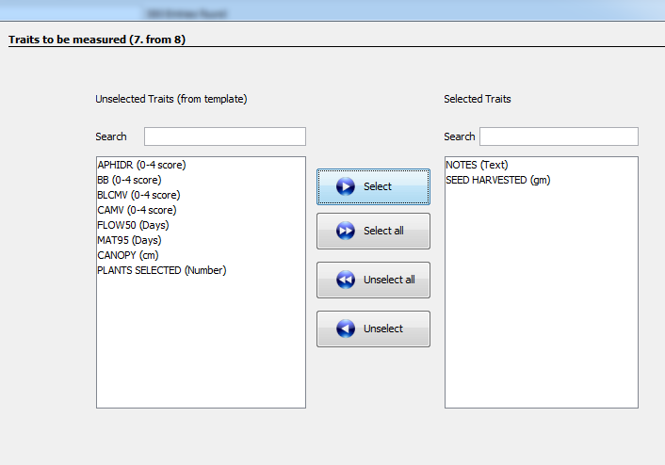

- Click Next, select unrandomized design (the default) and click Finish. Save the Nursery as BF2011F3H

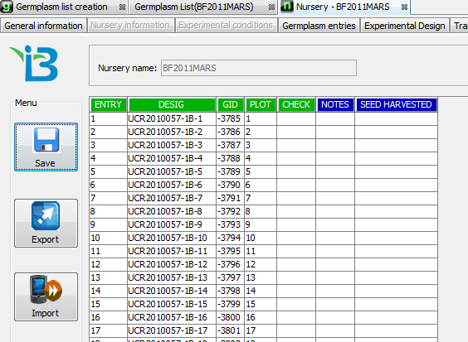
- Export the Nursery to and Excel file called BF2011F3H.xls. Open this file and add the harvest data in the columns NOTES and SEED HARVESTED (by cutting and pasting the column from the file BF2011MARSH.xls in your data directory). The workbook should look as follows:

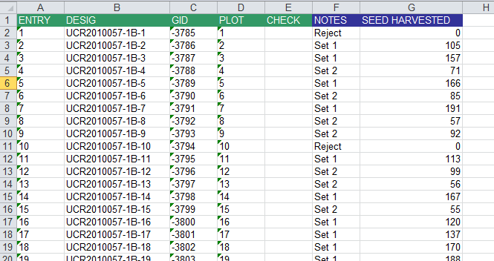

SEED HARVESTED contains fictitious yields of F2 seeds from each F2 plant and NOTES contain Set 1 if these was more than 100gm and Set 2 if there was some seed but less than 100 gm. Otherwise the plant is rejected.

Import this data into the BF2011F3H nursery.

